Operational Concept Description (OCD)

Amer I Can Re-Up

Team No. 9

TEAM MEMBERS ROLES
Siddharth Sohoni - Life Cycle Planner Requirements Engineer
Varun Brahme - Project Manager Prototyper
Suparna Dawalkar - Feasibility Analyst Software Architect
Priyanka Bhalerao - Prototyper Operational Concept Engineer
Anumeha Srivastava - Operational Concept Engineer Life Cycle Planner
Jeffrey Tonkovich - IIV&V Systems Engineer

November 28th 2011

Version History
Date | Author | Version | Changes made | Rationale
09/28/11 | AS | 1.0 | - Edited the Template – OCD for NDI/NCS | - Initial document
10/07/11 | AS,PB | 2.0 | - Modified section 2.2  - Modified section 2.3  - Modified Section 2.4  - Modified section 2.5  - Section 3.1  - Added section 3.2,3.3 and 3.4 | - Section 2.2 modified to include more capabilities according to Winbook  - Changed according to Benefits listed in Winbook  - new benefits chain diagram  - Corrected system boundary diagram  - Current system does not exist  - Included the new systems objectives, constraints, goals and the business workflow and element relationship diagrams
10/14/11 | AS,PB | 3.0 | - Edited section 3.2  - Edited section 2.4  - Edited section 3.3.1  - Edited section 3.3.2 | - Fixed bug and removed certain capabilities  - Improved Benefits Chain  - Improved Element relationship  - Added Business Workflow Diagrams
10/20/11 | AS,PB | 3.1 | - Edited section 3.2  - Edited section 2.4  - Edited section 3.3.1  - Edited section 3.3.2 | - Changed certain capabilities  - Improved Benefits Chain  - Improved Element relationship  - Modified and added Business Workflow Diagrams
10/24/11 | AS,PB | 3.2 | - Edited section 2.4  - Edited section 3.3.2 | - Improved Benefits Chain  - Modified Business workflows
11/21/11 | AS | 3.3 | - Edited section 2.4  - Edited section 3.3.1  - Edited section 3.3.2 | - Improved Benefits Chain  - Improved Element relationship  - Modified Business Workflow Diagrams
11/28/11 | AS | 3.4 | - Edited section 3.2 | - Added Capabilities

Table of Contents
Operational Concept Description (OCD) i
Version History ii
Table of Contents iii
Table of Tables iv
Table of Figures v
1. Introduction 1
1.1 Purpose of the OCD 1
1.2 Status of the OCD 1
2. Shared Vision 2
2.1 Success-Critical Stakeholders 2
2.2 System Capability Description 2
2.3 Expected Benefits 3
2.4 Benefits Chain 4
2.5 System Boundary and Environment 6
3. System Transformation 7
3.1 Information on Current System 7
3.2 System Objectives, Constraints and Priorities 7
3.3 Proposed New Operational Concept 9
3.4 Organizational and Operational Implications 10

Table of Tables
Table 1: Success-Critical Stakeholders 2

Table of Figures
Figure 1: Benefits Chain Diagram 5

Introduction

Purpose of the OCD
This document provides, in detail, the shared visions and goals of the stakeholders of the Amer I Can Re-Up website. The success-critical stakeholders of the project are Voltaire Davis and Will Wesley as the project owners, the prospective users and the future sponsors of the website.

Status of the OCD

The status of the OCD is currently version 3.3 in the valuation phase.
The scope of the login page and the profile page of the Amer I Can Re-Up project has been decided after the second Win-Win negotiation. Two capabilities have been added: Goals and Sacrifices. The benefits chain diagram has been modified .The element relationship diagram has been corrected. The business Workflow diagram has also been modified.

Shared Vision

Success-Critical Stakeholders
Table 1: Success-Critical Stakeholders
Stakeholder | Authorized Representatives | Organization | Relation to Benefits Chain
Client | Voltaire Davis  Will Wesley | Amer I can Re-Up | - Provide concept for the website  - Promote the website  - Test site using Focus groups
Developer | Team #9 | USC CSCI577a | - Implement code to develop the social reality website
End User¹ | N/A | N/A | - They are the ones who use the website for social accountability and hence make it popular
Sponsor | Don’t know yet* | Don’t know yet* | - Will contribute to the generation of profits by advertising on the site

* To be determined by the customer AFTER the project has been delivered.
1 For the end user, Authorized representative and organization is N/A since the website is for public use.

System Capability Description
This is a social reality website. Any web user can be the end user of the system. The system will provide the users with functionalities like
- A “ttBox” to add daily tasks and long term goals.
- Building your Squad (a group of friends- maximum size 25)
- People in your squad can grade you and hold you accountable(on the basis of the tasks done by you)
- Ability to search for other users
- Personal legend- a video-blog entry about oneself
- Statistics related to task completion (my G, Will Power, honor code, Task Totals)
- Status bar : with the option to select a motto or put up one’s own motto
- Theme song : uploaded by user (plays when all tasks in “ttBox” are complete)
- A report card with quarterly reports of statistics.(can be made public or private by user)
- Re- Ups- to provide helpful resources to your network (job postings, scholarships, internships etc)
Main competitors : Task management websites like www.taskfreak.com and www.hitask.com . Facebook, Google+ and any other successful social networking site.
Our website offers an edge over other competitors: Our website promotes productivity. Apart from just social networking or just task management, the system will hold the user accountable and will also provide the capability for other people to hold the user accountable for the tasks that the user has said that he/she will do.
It also promotes civic engagement.

Expected Benefits
- The system helps the users be more efficient, increase their productivity and help them meet their goals / dreams.
- By focusing on increasing the end-user’s productivity rather than being just another tool for communication, the system will have an edge over other social networking websites.
- Accountability (by system as well as user’s network)
- By hosting paid advertising from various sponsors on the website, the client will be able to monetize the system
- The site becomes a Global Brand.
- Social Reality emerges as a new Arena.
- A new culture emerges and social reality becomes an integral part of peoples’ life.

Benefits Chain
Assumptions:

- The concept of the site will be appealing to people.
- The site will act as a tool to promote productivity amongst its users.
- User-base increases with time which leads to increased revenue and investors’ interest in the website

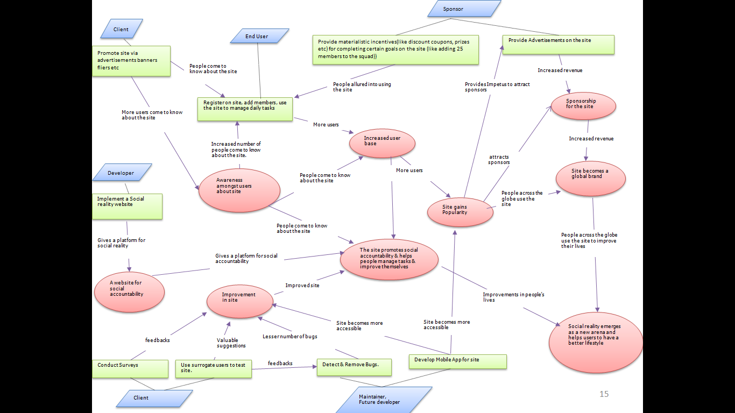

Figure 1: Benefits Chain Diagram
*new developers who will work for the client after csci 577ab to add the evolutionary requirements.

System Boundary and Environment

Register (sign up)
Login
Edit profile
Edit account settings
Change privacy settings
Add tasks
Add sacrifices
Get statistics
Upload Personal legend
Upload Motto
Grade other user

end users

maintainer

Internet
Support Infrastructure
Acquia Drupal Dev Desktop

Figure 2: System Boundary and Environment Diagram of Amer I Can Re-Up

System Transformation

Information on Current System

Infrastructure
The clients do not currently have an existing system. The website being developed currently only exists as an idea the client has and a series of power-point slides expounding on that idea.

Artifacts
The clients do not currently have an existing system. The website being developed currently only exists as an idea the client has and a series of power-point slides expounding on that idea.

Current Business Workflow
The clients do not currently have an existing system. The website being developed currently only exists as an idea the client has and a series of power-point slides expounding on that idea.

System Objectives, Constraints and Priorities

Capability Goals
Capability Goals | Priority Level
OC-1 : Login Page | Must have
OC-2 : Settings Page | Must have
OC-3 : Profile Page: Home for the user | Must have
OC-4 : ttBox – provides users the capability to input tasks | Must have
OC-5 : Personal Legend –users can upload a video about themselves | Must have
OC-6 : Statistics : My G, My Will, Honor Code, Task Totals | Must have
OC-7 : Status Message Bar : Motto or Free Speech | Must have
OC-8:Users can perform a simple query based search for other users | Must have
OC-9: Users have the ability to build their “squad” (25 people at max) | Must have
OC- 10 : A person’s squad can view his/her tasks and grade them. | Must have
OC-11: For Beta Version keep Squad and a public profile only | Must have
OC-12: Goals: 1 Major and 3 Minor Goals | Must have
OC-13:Status : option to post to the squad or keep public | Should have
OC-14: Sacrifices: Max 5 general sacrifices | Should have
OC-15 :Re-Up: option to post to the squad or keep public | Should have
OC-16: Report card with a summary of grades. If report card is implemented, the it must have quarterly grades. | Should have
OC-17: The report card has the capability of being public or private | Could have
OC-18 : Theme song plays when all tasks in ttBox are complete | Would like to have
OC-19 : Music uploads for theme song | Would like to have
OC-20 : A tutorial video on the website | Would like to have

Level of Service Goals
Table 2: Level of Service Goals

Level of Service | Priority
The system should be able to support 25000 users | Should Have (for Beta Version)
Note: As of now, this is the only level of service goal that the client has provided us with.
The client said that he would add more goals to this list as and when the site evolves.

Organizational Goals
The goals of the clients are:
OG-1: Own a system that helps the users be more efficient, increase their productivity and help them meet their goals / dreams.
OG-2: Generate profits via advertisements on the website
OG-3: Gain popularity and become a global brand.
OG-4: Social Reality becomes a new Arena.

Constraints

CO-1: The ability to run on a variety of browsers (i.e. Firefox 5+, IE7+, Chrome, Safari, etc)

CO-2: Extensibility to be a Mobile Application: The backend of the new system should be such that it can be extended later to be a mobile application later.

CO-3: Budget: $5000 for beta version.

Relation to Current System
The clients do not currently have an existing system. The website being developed currently only exists as an idea the client has and a series of power-point slides expounding on that idea.

Proposed New Operational Concept

Element Relationship Diagram
Drupal
ttBox Manager
Statistics
generator
“My squad” Manager
Settings
Manager
Media Manager
Add/retrieve statistics
Add/retrieve tasks
Modify settings
Fetch or Store song/Video
Add/remove members from the Squad
Display statistics
authenticate
User
username
password
Figure 3: Element Relationship Diagram of Amer I Can Re-up website
Note: All the things mentioned in boxes inside the dashed box will contribute to the system as different modules.

Business Workflow(s)

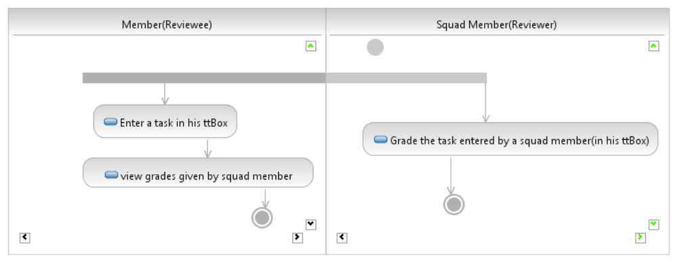
Figure 5: Business Activity Diagram for Grading a Squad Member

Organizational and Operational Implications

Organizational Transformations

Because there is no current system implemented, there will be no organizational transformations. The client will, however, need to:
• Hire a system maintainer (and probably other IT staff to provide support for the website)
• Obtaining the use of a data-center to host the website.

Operational Transformations
There is no existing system hence there are no existing workflows thus no transformations of workflows will take place due to the implementation of this system.

